**Format for uploading details in GitHub and Slack in word file format**

**Student Name: Shreetal kalabandi**

**Class and Sec: VI B**

**USN: 4AL17CS091**

|  |  |  |  |  |
| --- | --- | --- | --- | --- |
| **Online Test Details** | | | | |
| **Subject** |  | | | |
| **Semester** | **VI - B** | | **Duration** |  |
|  | |  | | |

**Encl: snapshot of the test result**

|  |  |  |  |
| --- | --- | --- | --- |
| **Certification Course Details** | | | |
| **Course** | **Python for machine learning** | | |
| **Certificate Provider** | **Cognitiveclass.ai** | **Duration** | **6 hours** |

**Encl: snapshots of the daily class activities (at least two snap shots)**

**Progress on 31-05-2020**

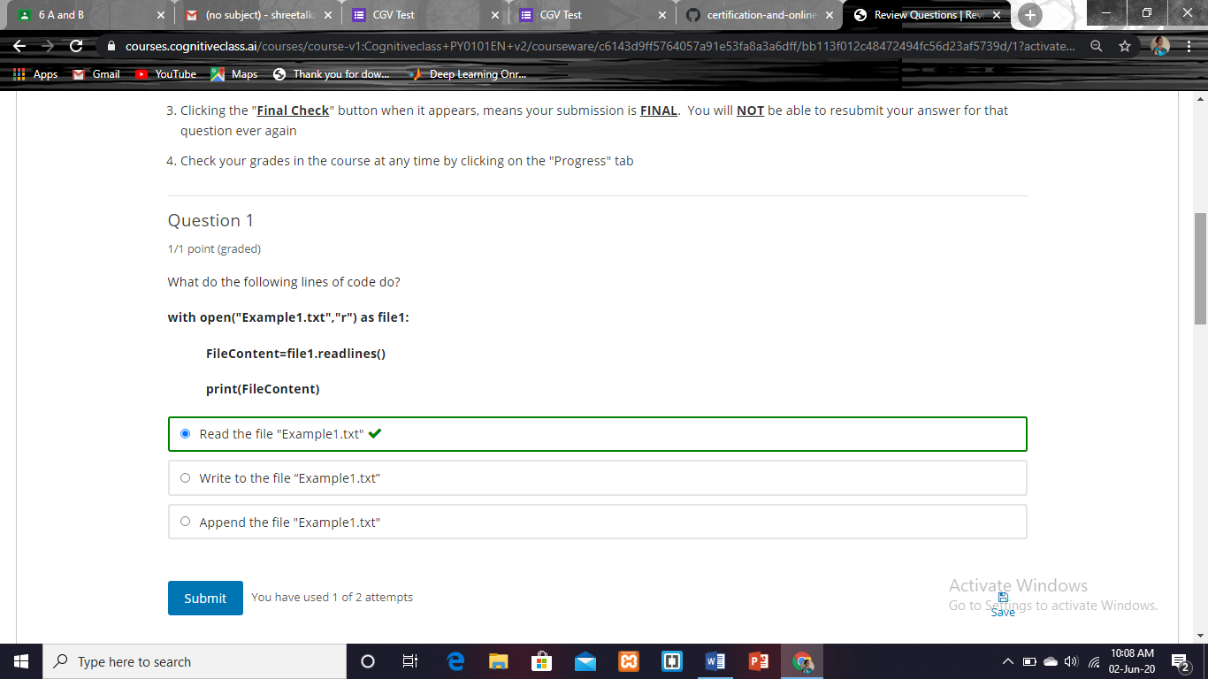

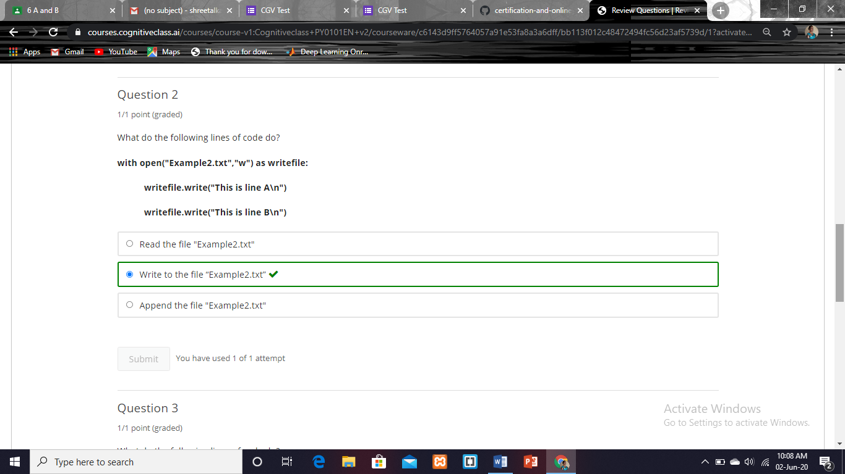

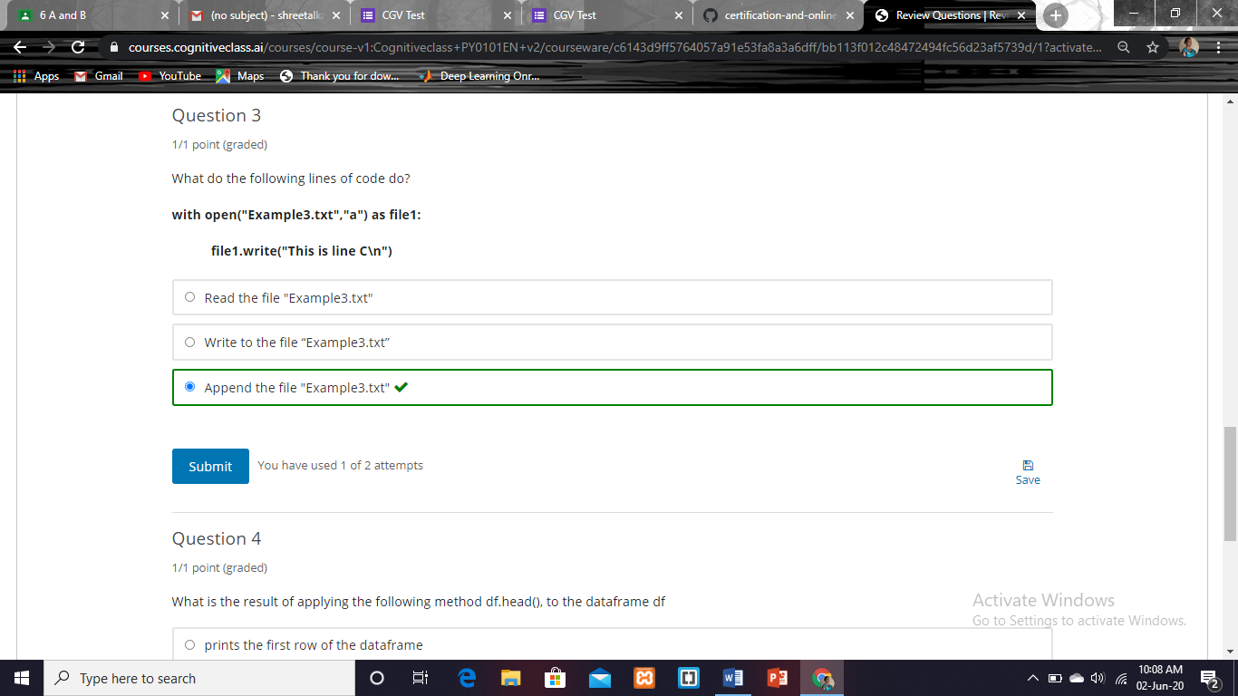

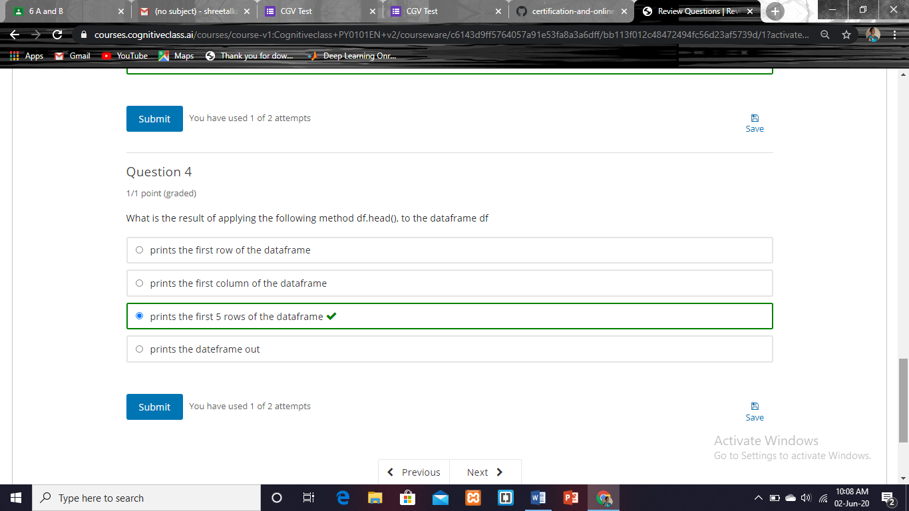

|  |  |
| --- | --- |
| **Coding Challenges** | |
| **Problem Statement:** | |
| **Status: Completed** | |
| **Uploaded the report both in GitHub & Slack** | **Yes** |

**Encl: snapshots of your response to challenge.**

